|  |  |  |  |
| --- | --- | --- | --- |
| SR.NO | DATE | TITLE | SIGN |
| 1. |  | Creating account, repository on GitHub and Cloning repository in GitHub Page |  |
| 2. |  | WRITING EMAIL |  |
| 3. |  | BASIC UNDERSTANDING ON FREE AND  OPENSOURCE SOFTWARE a) Describe  Open-  Source Software with Example. b) Describe  Free Software with Example c) Difference between Free and Open-Source Software. |  |
| 4. |  | INTRODUCTION and CONTRIBUTING TO  WIKIPEDIA a) What is Wikipedia? b) Steps to  Create Account on Wikipedia c) Creating  Page on Wikipedia d) Edit your page |  |
| 5. |  | Using practical examples, describe green  computing. List and explain the steps that you take to contribute to green computing |  |
| 6. |  | WRITING BLOGS |  |
| 7. |  | Implementing coding practices in Python using PEP8. |  |
| 8. |  | Importance of The Multidisciplinary Nature of Environmental Studies |  |
| 9. |  | Importance of Going Paperless |  |
| 10. |  | Define the terms renewable resource and non- renewable and give examples of each resource type that are related to forage  production |  |

## Practical 01 Creating account, repository on Github and cloning repository in Github Page.

### Creating Account:-

Go to github.com on your web browser.

Click on Sign up

Enter the details asked.

Click on ‘Create Account.

Verify your E-mail id.

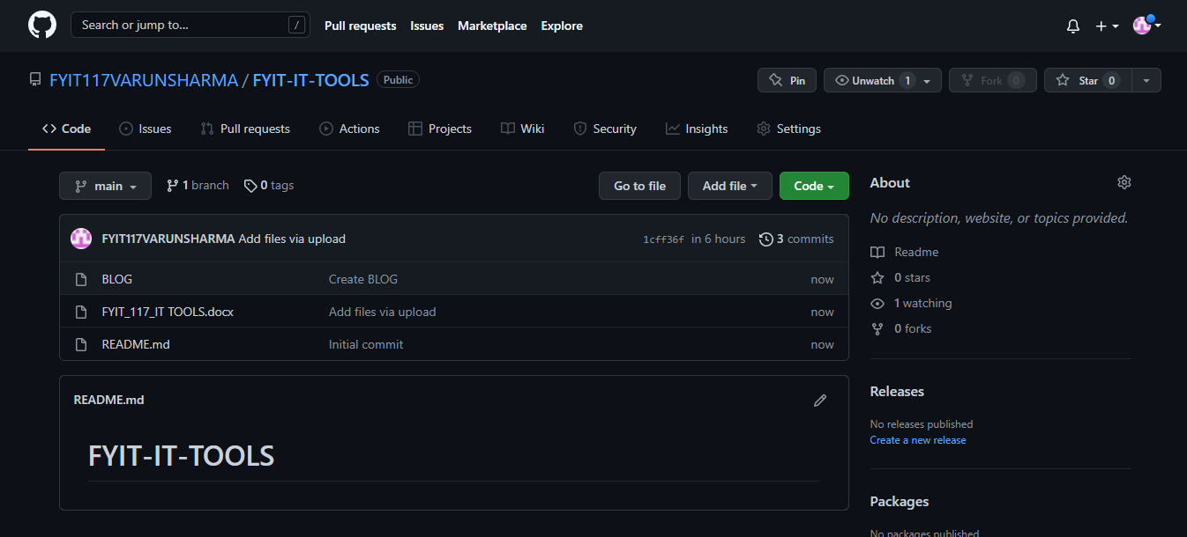

Click on New repository option

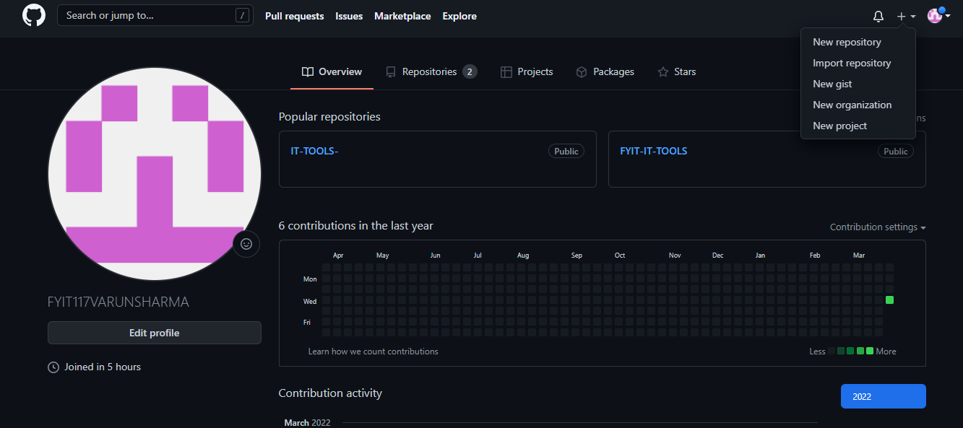

* After clicking New repository, name your project and choose the visibility and click on ‘Create Repository’ button.
* Now click on the ‘Upload files’ button and choose the file you want to upload.

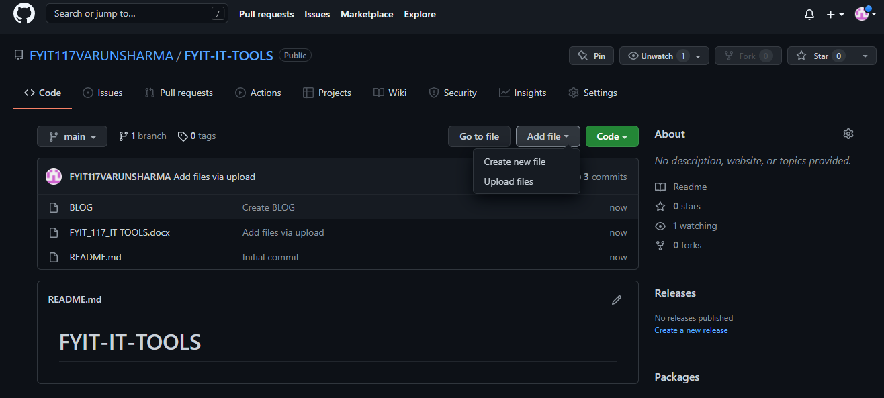

* After that now ‘Click on commit changes’ and you can see the uploaded files.

1. To clone the repository :- • To clone the repository select the link visible and paste where you want.

**Practical 02 Sending an E-mail.**

### Practical 02 Sending an E-mail:-

* Make sure you have an appropriate email id.

### On your device, go to Gmail.

* Click on “Compose”

### In the ‘To’ field add recipients.

### Write your Message

* And in the bottom of the page “click Send”.

### You can check your mail in the “sent” option available there.

### varun

# PRACTICAL 3. BASIC UNDERSTANDING ON FREE AND OPENSOURCE SOFTWARE.

### Describe Open-Source Software with Example.

Open source software is software with source code that anyone can inspect, modify, and enhance."Source code" is the part of software that most computer users don't ever see; it's the code computer programmers can manipulate to change how a piece of software—a "program" or "application"—works

maintains exclusive control over it—can modify. People call this kind of software "proprietary" or "closed source" software. Only the original authors of proprietary software can legally copy, inspect, and alter that software. And in order to use proprietary software, computer users must agree (usually by signing a license displayed the first time they run this software) that they will not do anything

### Describe Free Software with Example

A program is free software if the program's users have the four essential freedoms: The freedom to run the program as you wish, for any purpose (freedom 0). The freedom to study how the program works, and change it so it does your computing as you wish (freedom 1). Access to the source code is a precondition for this.The freedom to redistribute copies so you can help others (freedom 2).The freedom to distribute copies

|  |  |
| --- | --- |
| FREE SOFTWARE | OPEN SOURCE SOFTWARE |
| Software is an important part of people’s lives. | Software is just software. There are no ethics associated directly to it |
| Software freedom translates to social freedom | Ethics are to be associated to the people, not to the software |
| Freedom is a value that is more important than any economical advantage. | Freedom is not an absolute concept. Freedom should be allowed, not imposed. |

# Practical 4 Working with Wikipedia.

### What is Wikipedia?

Wikipedia is a free online encyclopedia that provides open content to its users. It is written collaboratively and openly by a community of both actual and self-proclaimed experts who call themselves Wikipedians. It was created Jimmy Wales and Larry Sanger and was initially slated to be a for-profit website used to support Wales' and Sanger's earlier venture into online encyclopedia space, Nupedia. It is a type of website designed to make collaboration and modification of both content and structure easy,

* + 1. Steps to create Wikipedia account.
       1. Open a Web browser to Wikia.com.
       2. Near the top there will be a Create Wiki button, click on it.
       3. Pick a name for your wiki, followed by a Web address.
       4. Sign up for an account on Wikia if you don't have one already.
       5. Enter a description for the type of wiki you are creating
       6. Pick a theme. And you are ready to use your account.

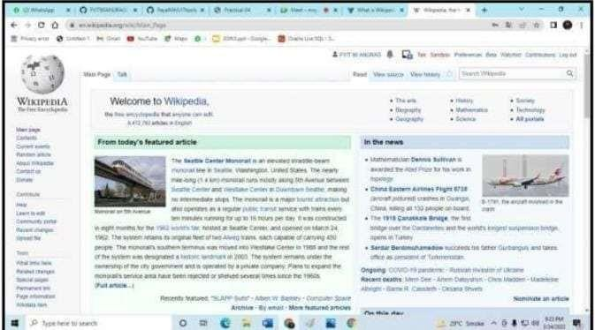

### Creating a page on Wikipedia.

* + - 1. To start with creating a page remember to Research Your Topic and Gather Resources
      2. Click on the sandbox and Create an outline.
      3. Write a draft of your wikipedia page.
      4. Submit your article for review.
      5. Publish your changes

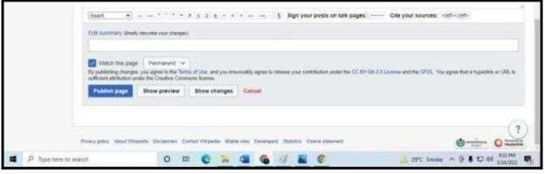

### Editing Wikipedia document.

* + - 1. Select the edit option.
      2. Edit your page.
      3. Publish change

**Practical 5 Using practical examples, describe green computing. List and explain the steps that you take to contribute to green computing.**

### Q1. What is Green Computing?

Green computing is an approach towards environmentally sustainable use of computing. It involves manufacturing, designing, disposing, and using computers and related resources effectively and efficiently with minimal to no negative effects on the environment. This sustainable approach helps save electricity and ensures computers generat

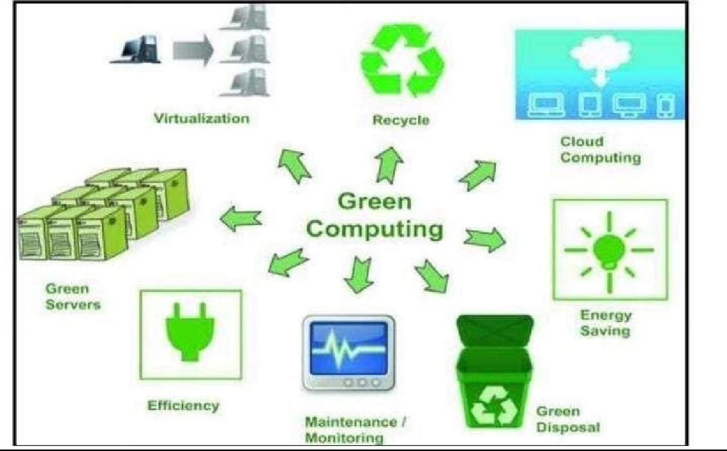

### Q2. Some examples of Green Computing.

1. Responsible handling of electronic equipment is critical in order to minimize the university’s impact on the environment. Companies like Dell, Inc and Mac, Inc are adapting sustainable, environmentally responsible practices and standards which apply for the life of their computers, from design, production and packaging to recycling after the machine’s useful life has ended.
2. Outdated Apple equipment is processed through Apple’s Trade-In Program, often for purchase credit. Apple either refurbishes the equipment or

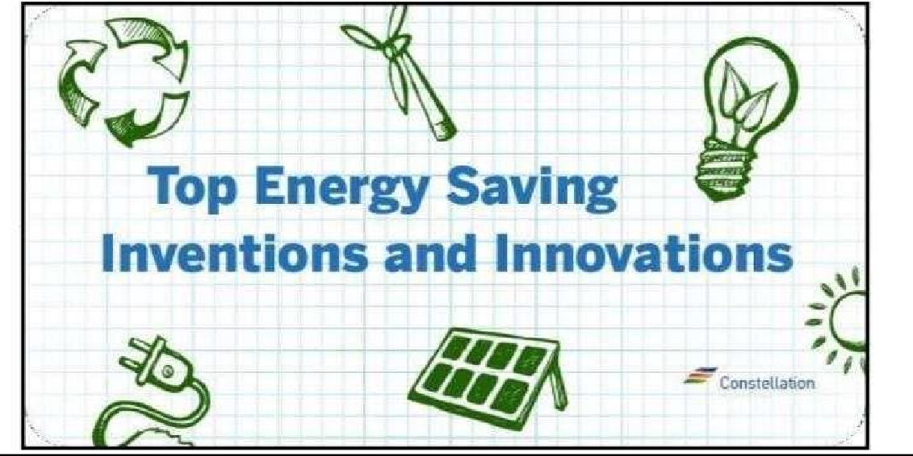

Appointment of a Working Group for Green IT Compliance Assurance

: Once the ball is set to roll, you need to have a committee that will monitor and ensure that the company’s plans are adhered to by all members of the organization. One of the most important tasks that the appointed Green IT Committee must focus on is the acquisition of energy efficient IT infrastructure. This team should make sure that the IT groundwork meets all the criteria that are set for the protection of the environment.

* 1. Measurement of Current Carbon Footprints Produced by IT Components:

Where the company stands in terms of carbon footprint brought about by information technology services, is an important information to be known. Quickly establish a carbon footprint reference point. Check on the power usage in the IT center and compare it with existing power efficiency standards and metrics for industry.

* 1. Planning More Centralized IT Operations: It is relatively easy for an organization to centralize its information technology (IT) system. With server virtualization, carbon footprints can be significantly reduced
  2. Usage of More Efficient Computer Applications: By using more powerful computer applications, your IT systems can better deal with inefficiencies. Besides, faster software spares the servers from regularly operating at maximum capacity, thereby consuming lesser power. If one can only increase the speed of the computer applications that is used, one can have a corresponding positive effect on the energy use and carbon emissions.
  3. Usage of More Efficient Cooling Systems: To reduce your CRAC (Computer Room Air Conditioning) power consumption for green computing, invest in supplemental cooling systems that are placed in between the rows of servers in data center. Thus, they can minimize the number of timesin a day that the bigger CRAC units are required to work on full power. Apply new Data-Centre design technology that minimizes hotzones.
  4. Careful Weightage of Life-cycle of IT Devices and Accessories: Consider the projected life-cycle of existing IT hardware. Can it be recycled? Will it decay in time? If not, then disposing of existing hardware can far outweigh the environmental benefits that you intend to achieve by buying newer more power-efficient computer hardware.
  5. Business Performance Enhancement through Green IT Policies: Make sure that the drive for a green IT fits in your overall business operation. BetterWork with Everyone Involved in IT Process Life-cycle: Now that you have taken the steps to ensure that company uses green IT, you need to get everyone involved in the initiative. The human resources department can support initiatives by regularly posting announcements and notices that touch on the subject of environment-friendly computing.

1. Result Monitoring and Continuous IT Optimization: Lastly, you should always check the results of green IT initiatives. Compare this data with the benchmarks and metrics that is set for the company. A good example is checking total power consumption for each month. If it has significantly dropped, then one can say that we have effectively reduced your organization’s carbon footprint



# Practical 06 Writing Blogs.

A blog is a discussion or informational website published on the World

Wide Web consisting of discrete, often informal diary-style text entries (posts). Posts are typically displayed in reverse chronological order, so that the most recent post appears first, at the top of the web page. Site used : [https://ww](http://www.blogger.com/blog/post/edit/774740526827557896/21416729)w.blog[ger.co](http://www.blogger.com/blog/post/edit/774740526827557896/21416729)m/[blog/post/edit/774740526827557896/21416729](http://www.blogger.com/blog/post/edit/774740526827557896/21416729) 6349819398 0

Wix.com Ltd. is an Israeli software company publicly listed in the US that provides cloud-based web development services. It allows users to create HTML5

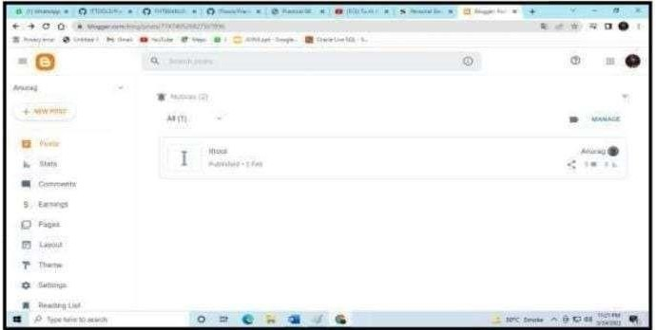

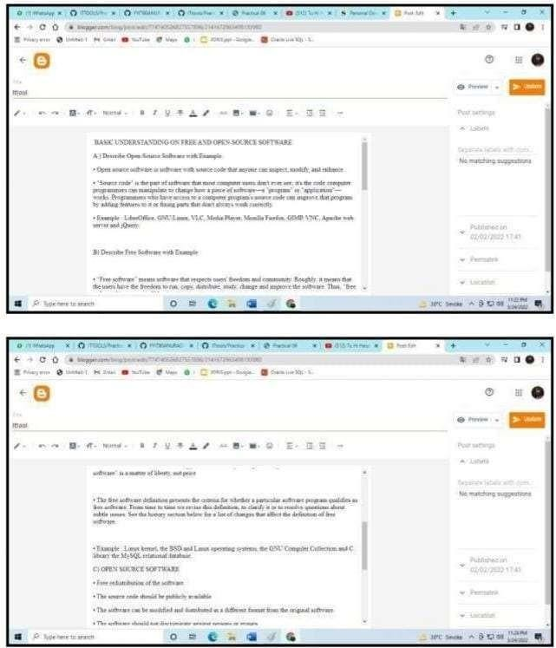



Practical 07 Implementing coding practices in Python using PEP8

### What is Pep ?

The PEP is an abbreviation form of Python Enterprise Proposal. Writing code with proper logic is a key factor of programming, but many other important factors can affect the code's quality. The developer's coding style makes the code much more reliable, and every developer should keep in mind that Python strictly follows the order and format of the string.

Adapting a nice coding style makes the code more readable. The code becomes easy for the end-user

PEP 8 is a document that provides various guidelines to write the readable in Python. PEP 8 describes how the developer can write beautiful code. It was officially written in 2001 by Guido van Rossum, Barry Warsaw, and Nick Coghlan. The main aim of PEP is to enhance the readability and consistency of code.

### Naming Convention :-

When we write the code, we need to assign name to many things such as variables, functions, classes, packages, and a lot more things. Selecting a proper name will save time and energy.

Single lowercase letter 1. a = 10

Single upper case letter 1. A = 10

Lowercase 1.

var = 10 Lower_case_with_underscores

1. number_of_apple = 5 UPPERCASE

1. VAR = 6 UPPER_CASE_WITH_UNDERSCORES

|  |  |  |
| --- | --- | --- |
| TYPE | NAMING CONVENTION | EXAMPLES |
| Function | We should use the lowercase words by the underscore.words or separates | Myfunction,my_function |

|  |  |  |
| --- | --- | --- |
| Variable | We should use a lowercase letter, words, or separate words to enhance the readability | a,var,variable_name |
| Class | The first letter of class name should be capitalized; use camel case. Do not separate  words with the underscore. | MyClass,Form, Model |
| Method | We should use a lowercase letter, words, or separate words  to enhance readability. | Class method, method |
| Constant | We should use a short,uppercase letter, words, or separate words to enhance  the readability. | MYCONSTANT, CONSTANT, MY CONSTANT |
| Module | We should use a lowercase letter, words, or separate words to enhance the readability. | Module_name.py, module.py |
| Package | We should use a lowercase letter, words, or separate words to enhance the readability. Do not separatewords with the underscore | package, mypackage, |

### Code Layout:-

Indentation: Unlike other programming languages, the indentation is used to define the code block in Python. The indentations are the important part of the Python programming language and it determines the level of lines of code. Generally, we use the 4

For eg.

# first line doesn't has any argument

# We add 4 spaces from the second line to discriminate arguments from the rest. def function_name( argument_one, argument_two, argument_three, argument_four): print(argument_two)

# 4 space indentation to add a level. foo = long_function_name( var_one, var_two, var_three, var_four)

Use docstring

Python provides two types of document strings or docstring-

* Single line
* Mul ple line

We use triple quotes to define a single line or multiline quotes. Basically, these are used to describe the function or particular program For eg.

def add(a, b):

"""This is simple add method""" """

This is a

simple add program to add

the two numbers. """ The line break before or after a Binary operation is a traditional approach. But it affects the readability extensively because the operators are scattered across the different screens, and each operator is kept away from its operand and onto the previous line.

For eg.

# easy to match operators with opera

+ math_marks

+ (science_marks - biology_marks)

+ physics_marks Importing Module We should import modules in separate lines as follows:

import pygame import os importsys OR

from subprocess import Popen, PIPE

The import statement should be written at the top of the file or just after any module comment. Absolute imports are the recommended because they are more readable and tend to be better behaved. import mypkg.sibling from mypkg import sibling from mypkg.sibling import example

However, we can use the explicit relative imports instead of absolutes import, especially dealing with complex packages.

Blank Lines

Blank lines can improve the readability of Python code.

Top-level function and classes with two lines- Put the extra vertical space around them so that it can be understandable. class FirstClass: pass class SecondClass:

pass def main_function():

return None

1. Single blank line inside classes- The functions that we define in the class is related to one another. class FirstClass:

def method_one(self return None def second_two(self): return None

# PRACTICAL 8: Importance of The Multidisciplinary Nature of Environmental Studies

The word environment is derived from the French word ‘environner’ which means to ‘encircle or surround’. Thus our environment can be defined as “the Social, Cultural and Physical conditions that surround, affect and influence the survival, growth and development of people, animals and plants”. This broad definition includes the natural world and the technological environment as well as the cultural and social contexts that shape human lives.

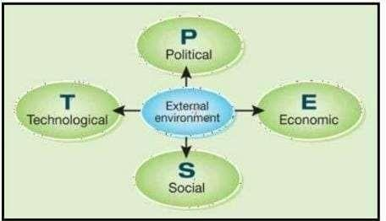

Environmental Study is a vast subject to be studied upon. It has all the aspects of various subjects such as anthropology, science, social science, statistics, economics, computers, geology, health, and sociology. It illustrates the multi- sectoral and mul dimensional study in various fields. It also educates us about the Physical, Social, Cultural, and Biological aspects.

It brings our natural environment and human impacts altogether. It is a multidisciplinary approach that deals with every issue that affects an organism. It covers the impacts of environmental science and social aspects of the environment as well.

Why is EVS known as the Multidisciplinary Nature of Environmental Studies?

Environmental Studies consist of different components. They are listed below:

* + Anthropology – It is the study of human characteristics, their biological and psychological wellbeing, their societies and cultures, their development and evolution. EVS is related to anthropology as it deals with the study of humans and their environment as well across space and time.
  + Biology – It is a branch of science that is concerned with the study of living organisms. It includes their physical structure, chemical processes, molecular interactions, development, and evolution. EVS is related to biology as it deals with the natural habitat of the living organisms.
  + Chemistry – It is a branch of science that studies chemicals and the substances of which matter is composed of. In EVS, for the understanding of natural phenomena, we require knowledge of chemistry.
  + Computers – With the advancing world, computers have become everyone’s requirement. The Environmental Protection Agency uses computers to maintain a record and to investigate chemicals that are used in soil and water.
  + Economics – It is a branch of knowledge that is concerned with the production, consumption, and distribution of goods and services. To protect the environment from pollution, global warming, and climate change, various economic policies have been developed in analysing and finding solutions or remedies for environmental issues.

How the Multidisciplinary Nature of Environmental Studies helps in solving environmental problems?

Environmental Studies deals with various areas – conservation of natural resources, controlling pollution, the impact of the growing human population on the environment. A multidisciplinary nature is required to address these complex environmental problems. These problems are connected with different sectors like agriculture, land degradation, economic loss, contamination of natural resources, forestry, habitat fragmentation, ozone layer depletion, solid waste management, etc. The emerging climatic and environmental concerns need multidisciplinary solutions. Environmental issues are an alarming indication of upcoming disasters. Therefore, to gain knowledge about these issues, the Multidisciplinary Nature of Environmental Studies is a must.

There are various ways in which our environment can be conserved. Some of them are listed below:

* + Replacing disposal items with reusable ones.
  + Proper disposal of wastes
  + Recycling of paper, plastics, etc.
  + Neutralizing the poisonous emissions by the factories
  + Conserve resources like water and electricity
  + Support eco-friendly products more
  + Afforestation and reforestation
  + Enhancement of the use of public transport
  + Limit the use of paper
  + By spreading awareness about the importance of the environment

A pure, harmless, and pollution-free environment is every individual’s right. These issues can be solved when people acquaintance with the need of conserving the environment. For this, knowledge of Environmental Studies is needed.

Conclusion

EVS is a multidisciplinary academic field that is involved with the exploration, research, and expansion of an understanding of the living an

## PRACTICAL 9: Importance of Going Paperless

“Going Paperless” is a term that was coined not so long ago to describe the processes of “reducing the amount of paper used in a business context, exchanging printed pages for digital documents especially in internal processes.”

Common paperless areas of choice by companies include receipts, invoices, tax returns and pay checks, among others. Areas that manual work adds no real value to the company and the steps required to have its work done are too time-consuming.

It should not be a surprise that, once this wave started, it was only a matter of time for it to become bigger. This happened mainly because of the rise of

1. Document organization

The ability to quickly locate and disseminate information may enhance your company's efficiency and professional image. Spending time hunting through piles of paper slows down response time in an age when most answers are only a few keystrokes away. By scanning electronic copies of receipts and invoices, documents can be sorted, filed, and organized for quick retrieval when it matters most. 2. Client communication is faster and less expensive

By maintaining a customer email list, you can instantaneously communicate sales and special offers without incurring postage and printing expenses. With the advanced technology of smart devices, most people have immediate access to emails. While it increases efficiency, electronic communication also decreases storage costs as the amount of paper copies littering your office will begin to dwindle.

* 1. Paperless files are easily saved and retrieved on the go

With the advent of photo-scanning apps, business travellers can easily back up expense reports without needing to save a pile of papers to bring back to the office. Electronic files can also be shared with coworkers over a network or via email. Shifting to paperless documentation also makes the transportation of data more efficient, without the need for cumbersome fax machines or document couriers.

* 1. Automatic backups

When you accidentally throw out an important paper, it's usually gone forever. However, maintaining electronic files allows for multiple backup points. Data can be saved on flash drives, in the cloud, or to an external hard drive. For vitally important financial data, cloud-based accounting systems provide automatic backups on a pre-scheduled basis, which eliminates the need for small business owners to set aside time for manual backups.

* 1. Data security

## PRACTICAL 10: Define the terms renewable resource and nonrenewable and give examples of each resource type that are related to forage production

A natural resource is something supplied by nature that helps support life. When you think of natural resources, you may think of minerals and fossil fuels. However, ecosystems and the services they provide are also natural resources. Biodiversity is a natural resource as well.

Renewable Resources Renewable resources can be replenished by natural processes as quickly as humans use them. Examples include sunlight and wind. Metals and other minerals are renewable too. They are not destroyed when they are used and can be recycled.

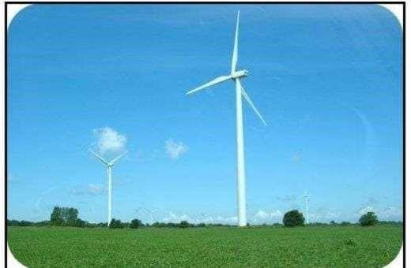

Wind is a renewable resource. Wind turbines like this one harness just a tiny fraction of wind energy.

Living things are considered to be renewable. This is because they can reproduce to replace themselves. However, they can be over-used or misused to the point of extinction. To be truly renewable, they must be used sustainably. Sustainable use is the use of resources in a way that meets the needs of the present and also preserves the resources for future generations.

Non-renewable Resources

Non-renewable resources are natural resources that exist in fixed amounts and can be used up. Examples include fossil fuels such as petroleum, coal, and natural gas. These fuels formed from the remains of plants over hundreds of millions of years. We are using them up far faster than they could ever be replaced. At current rates of use, petroleum will be used up in just a few decades and coal in less than 300 years. Nuclear power is also considered to be a non-renewable resource because it uses up uranium, which will sooner or later run out. It also produces harmful wastes that are difficult to dispose of safely.

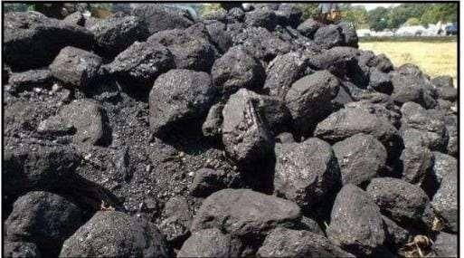

|  |  |
| --- | --- |
| Renewable resources | Non-renewable resources |
| Solar Energy | Oil |
| Soil | Steel |
| Trees | Aluminium |
| Grass | Coal |
| Groundwater | Phosphates |